  
**THE PURPOSE OF A SYSTEM PLATFORM IS TO CONCEAL ELECTRICS, AV CABLES, WATER AND WASTE PIPES.**

.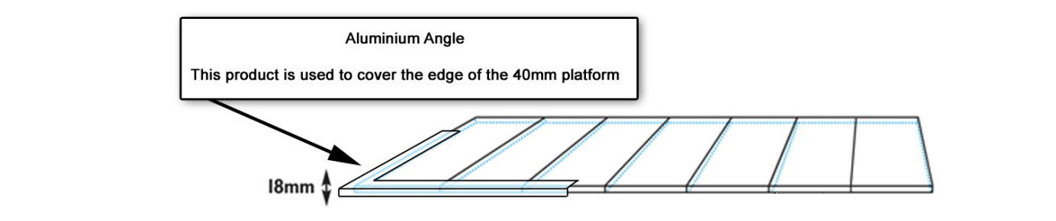

**18mm platform**

The 18mm platform option is used in venue’s where the hall floor already has carpet tiles laid. Once the 18mm platform option is installed any carpet, vinyl or laminate can be fitted on it.

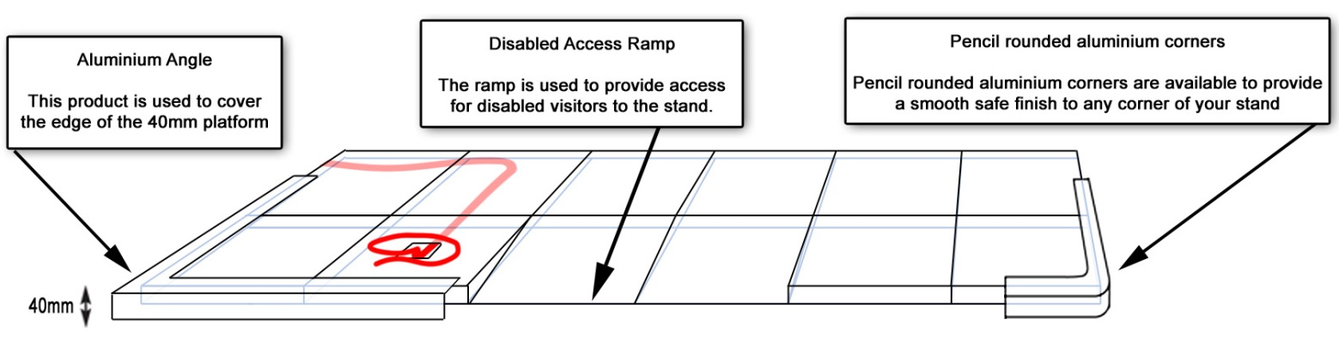

**40mm Platform**

If your stand requires cables to be laid under the platform but you prefer a lower level floor then we recommend our 40mm platform.  Please note water & waste pipes cannot fit under this option.

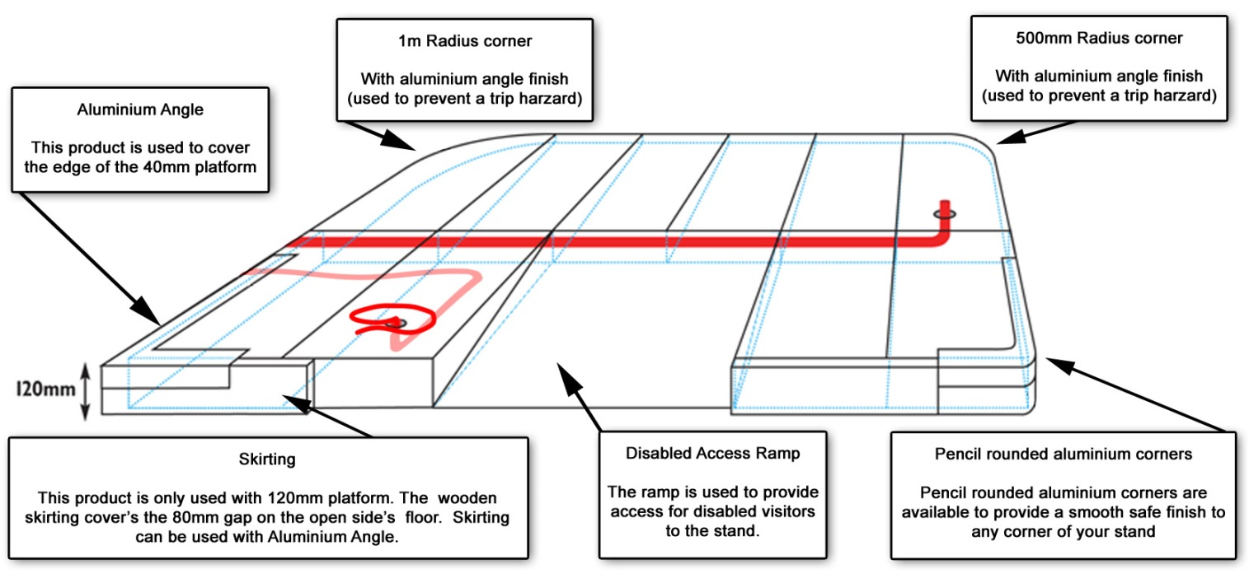

**120mm platform**

If your stand requires a large number of cables or water & waste pipes to be installed then we recommend the 120mm platform system.



|  |  |
| --- | --- |
| **Exhibitor** |  |
| **Install Date & Time** | select install date / enter install time |
| **Stand Type** | select stand type |
| **Stand Number** |  |
| **Hall** |  |
| **Address** |  |
| **Post Code** |  |
| **Contact Name** |  |
| **Tel Number** |  |

## THE PLATFORM HIRE SPECIALIST

Expo Floors Ltd, Units A4 & A5, Walsall Ent. Park,

Regal Drive, Walsall, WS2 9HQ

Tel: 01922 721177 Fax: 01922 659540

E-mail: [sales@expo-floors.com](mailto:sales@expo-floors.com) [www.expo-floors.com](http://www.expo-floors.com)

**RETURN BY : 19th August 2019**

**CONTACT : Jake Tatlow**

Orders received after the ‘return by’ date   
will be subject to a 20% surcharge

**EXHIBITION : SFFF 2019**

**VENUE: Olympia London**

**DATES: 1 – 3rd Sept 2019**

## A MINIMUM CHARGE FOR PLATFORMS UNDER 25M2,

**PRICE ON APPLICATION**

|  |  |  |  |  |
| --- | --- | --- | --- | --- |
|  | **DESCRIPTION** | QUANTITY | **ITEM COST** | **TOTAL** |
|  | Platform 120mm       x |  | £16.95 PER M2 |  |
|  | Platform 40mm       x |  | £15.95 PER M2 |  |
|  | Platform 18mm       x |  | £15.95 PER M2 |  |
|  | Aluminum Edging  (must be ordered with 18mm & 40mm platforms) |  | £7.50 PER LM |  |
|  | Skirting  (must be ordered with 120mm platform) |  | £4.50 PER LM |  |
|  | Ramp 1m x 1m |  | £45.00 PER Ramp |  |
|  | Ramp 1m x 500mm |  | £40.00 PER Ramp |  |
|  | Pencil Rounded Aluminum Corners |  | £20.00 PER Corner |  |
|  | 500m Radius Corner with Aluminium Angle Finish |  | £87.00 PER Corner |  |
|  | Click Laminate Flooring (7mm)  (cannot go direct to hall floor) |  | £27.50 PER M2 |  |
| **Payment Methods**.  Cheque made payable to Expo Floors Ltd  All major credit cards accepted, except for American Express | | | Sub Total |  |
| VAT @ 20% |  |
| TOTAL |  |

**IMPORTANT SERVICES FLOORING GRID**

**COMPANY NAME:       STAND NO:**

**Please specify scale (e.g. 2 squares = 1m):**

**SERVICES FLOORING GRID**



Using the grid, draw outline of your floor area and mark on it the relevant points with the stand orientation i.e. **x, c** depending on their location. For large areas please send dimension drawing.

**Please utilise the symbol below to indicate the position of all orders – copy and paste the symbol into a blank space before moving onto the grid:**

**Key:**

**Walling to represent your stand size =**

**Electric point =**

**Water & waste =**

**Mains point =**

**Hall columns =**



**Ramps =**

**STAND DETAILS:**

Space Only

Shell Scheme

Additional Information

**If you do not send us a diagram to indicate the positioning of all orders, items may be placed incorrectly. Subsequent change will incur a charge.**

**Please return to: Expo Floors Ltd**

**Units A4 & A5, Walsall Ent. Park, Regal Drive, Walsall, WS2 9HQ**

Tel: **+44 (0)1922 721177** Email: [**sales@expo-floors.com**](mailto:sales@expo-floors.com)